# Exno:1 User Interface Design 230701199

# BAD Design

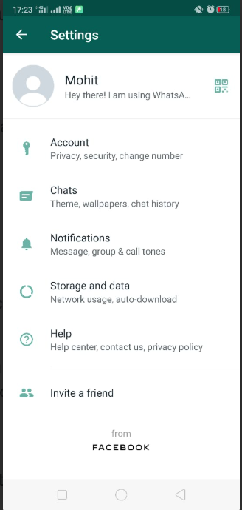

Why it is bad design?

The above design is not much colourful and it has no special features like directly opening Instagram and facebook.The icons are also not catchy in this.This design will not attract people.

# Good Design

# 

Why is it Good design ?

The above is good design because it is more attractive and colourful and it attracts people easily .Comparitively to the bad design the good design has good icon position.We can open Instagram and facebook directly from this design.

Done by Muhammad Asif P A(230701199)